SCHOOL OF COMPUTER SCIENCE AND ARTIFICIAL INTELLIGENCE |  |  |  |  | DEPARTMENT OF COMPUTER SCIENCE ENGINEERING
ProgramName:B. Tech |  |  |  | Assignment Type: Lab |  |  | AcademicYear:2025-2026
CourseCoordinatorName |  |  |  | Venkataramana Veeramsetty
Instructor(s)Name |  |  |  | Dr. V. Venkataramana (Co-ordinator)  Dr. T. Sampath Kumar  Dr. Pramoda Patro  Dr. Brij Kishor Tiwari  Dr.J.Ravichander  Dr. Mohammand Ali Shaik  Dr. Anirodh Kumar  Mr. S.Naresh Kumar  Dr. RAJESH VELPULA  Mr. Kundhan Kumar  Ms. Ch.Rajitha  Mr. M Prakash  Mr. B.Raju  Intern 1 (Dharma teja)  Intern 2 (Sai Prasad)  Intern 3 (Sowmya)  NS_2 ( Mounika)
CourseCode |  |  | 24CS002PC215 | CourseTitle |  | AI Assisted Coding
Year/Sem |  |  | II/I | Regulation |  | R24
Date and Day  of Assignment |  |  | Week3 - Wednesday | Time(s)
Duration |  |  | 2 Hours | Applicableto  Batches
AssignmentNumber:6.3(Present assignment number)/24(Total number of assignments)
 | Q.No. | Question |  |  |  |  |  | ExpectedTime  to complete
 | 1 | Lab 6: AI-Based Code Completion – Classes, Loops, and Conditionals  Lab Objectives:  - To explore AI-powered auto-completion features for core Python constructs.  - To analyze how AI suggests logic for class definitions, loops, and conditionals.  - To evaluate the completeness and correctness of code generated by AI assistants.  Lab Outcomes (LOs):  After completing this lab, students will be able to:  - Use AI tools to generate and complete class definitions and methods.  - Understand and assess AI-suggested loops for iterative tasks.  - Generate conditional statements through prompt-driven suggestions.  - Critically evaluate AI-assisted code for correctness and clarity.  Task Description#1 (Classes)  - Use AI to complete a Student class with attributes and a method.  - Check output  - Analyze the code generated by AI tool  Instructions:  - Initialize class with attributes like name, roll no, marks  - Method to display student details  - Method to calculate grade based on marks (A:>=90, B: >=75, C: >=60, else Fail)  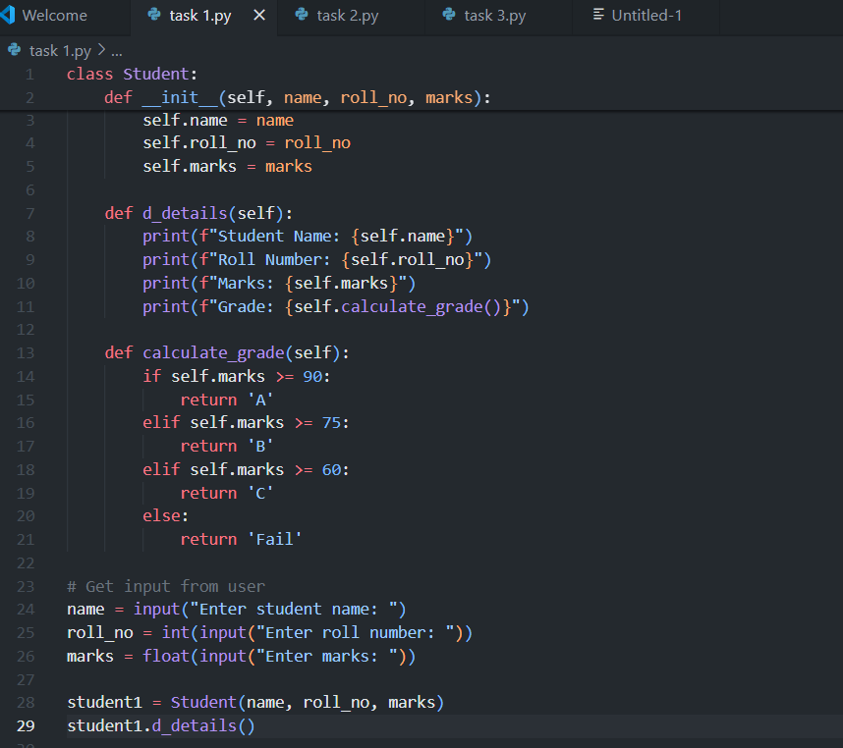  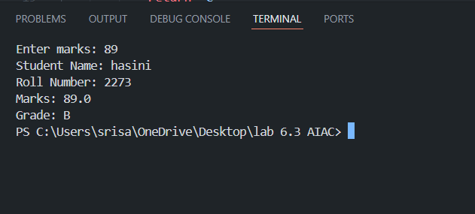  Explanation; The given prompt is to initialize the class with attributes like name roll marks the details should be displayed  So I have give the details that should I enter the values after running the code so that I used the (if else statement )to estimate the marks and give the grades.Give marks if above 90 that gives A grade. and if marks 80 it gives B grade etc.this is possible by if else statement.  Start Writing code and auto complete using any AI tool  Expected Output#1  - Class with constructor and display_details() method  Task Description#2 (Loops)  - Prompt AI to complete a function that prints the first 10 multiples of a number using a loop.  - Analyze the generated code  - Ask AI to generate code using other controlled looping  Write code using For Loop, later complete code using While Loop  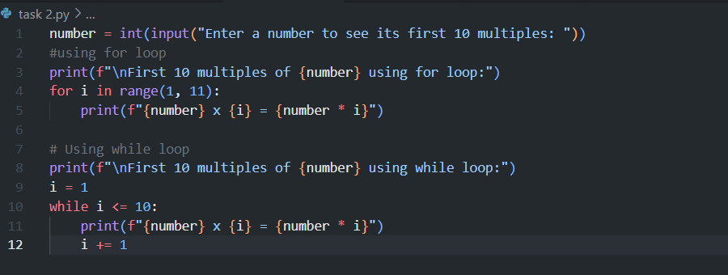  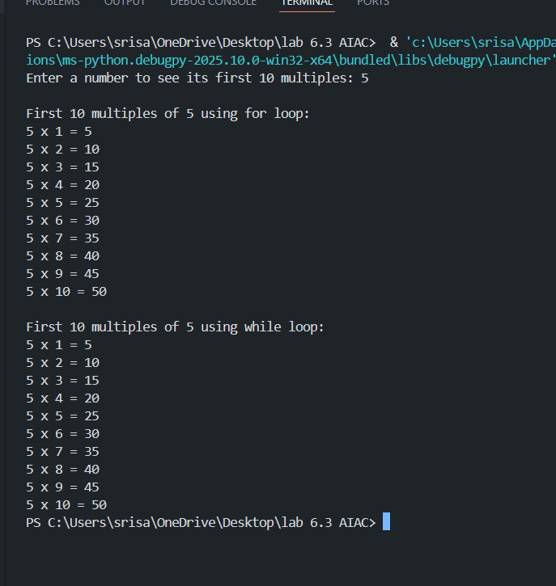  Explanation: The given prompt is if enter a value between 1 to 10 is should give the multiples of that number.  So in this code we should use‘ FOR ‘and ‘WHILE’loop because the numbers should multiply in a range if we give the condition for we can asily loop the numbers in the case of multiplication  Expected Output#2  - Correct loop-based implementation  Task Description#3 (Conditional Statements)  - Ask AI to write nested if-elif-else conditionals to classify age groups.  - Analyze the generated code  - Ask AI to generate code using other conditional statements  - 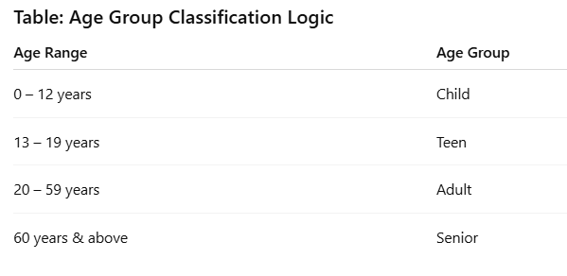  Expected Output#3  - Age classification function with appropriate conditions and with explanation  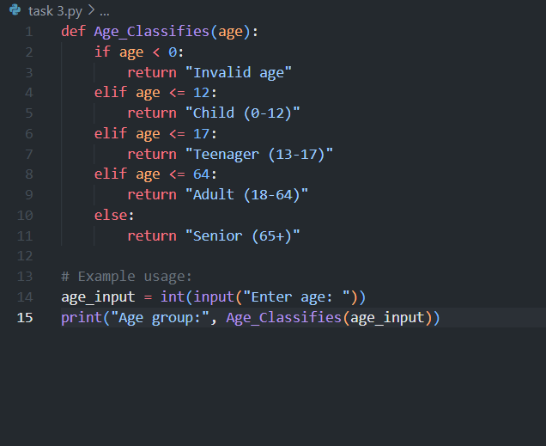  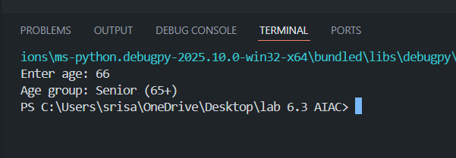  EXPLANATION :  THE GIVEN PROMPT IS WE SHOULD CLASSIFY AGE GROUP .CLASSIFICATION LIKE CHILD,ADULT,OLD  SO WE SHOULD USE IF ELSE CONDITION BECAUSE WE ARE CLASSIFYING THE AGE GROUP BY GIVING A RANGE  Task Description#4 (For and While loops)  - Generate a sum_to_n() function to calculate sum of first n numbers  - Analyze the generated code  - Get suggestions from AI with other controlled looping  Expected Output#4  - Python code with explanation  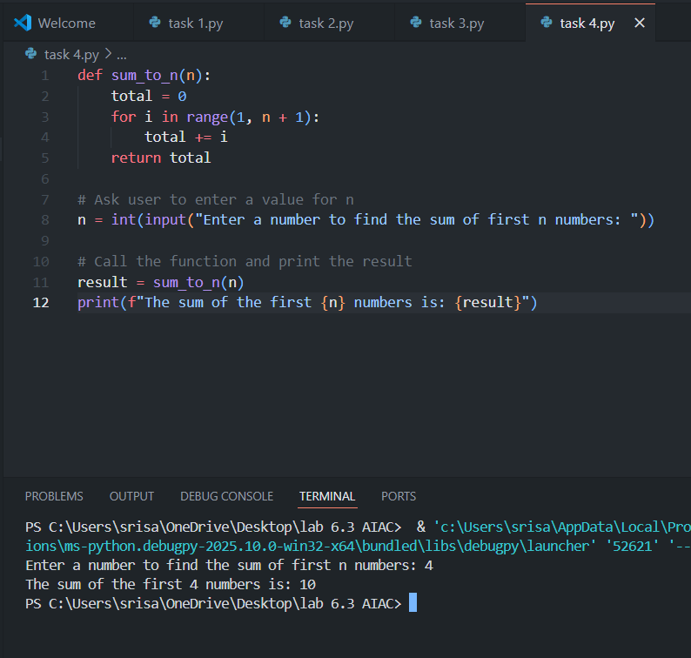  EXPLANATIAON : THE GIVEN PROMPT IS WE SHOULD CALCULATE THE 1ST N NUMBERS.  SO IN THIS CODE WE SHOULD USE ‘FOR’ CONDITION BEACAUSE THE NUMBERS SHOULD BE CALCUTAED IN LINE WISE LOOP .  Task Description#5 (Class)  - Use AI to build a BankAccount class with deposit, withdraw, and balance methods.  - Analyze the generated code  - Add comments and explain code  Instructions  - Initialize BankAccount class with attributes like name, balance  - Method to deposit amount  - Method to withdraw amount  - Method to check balance  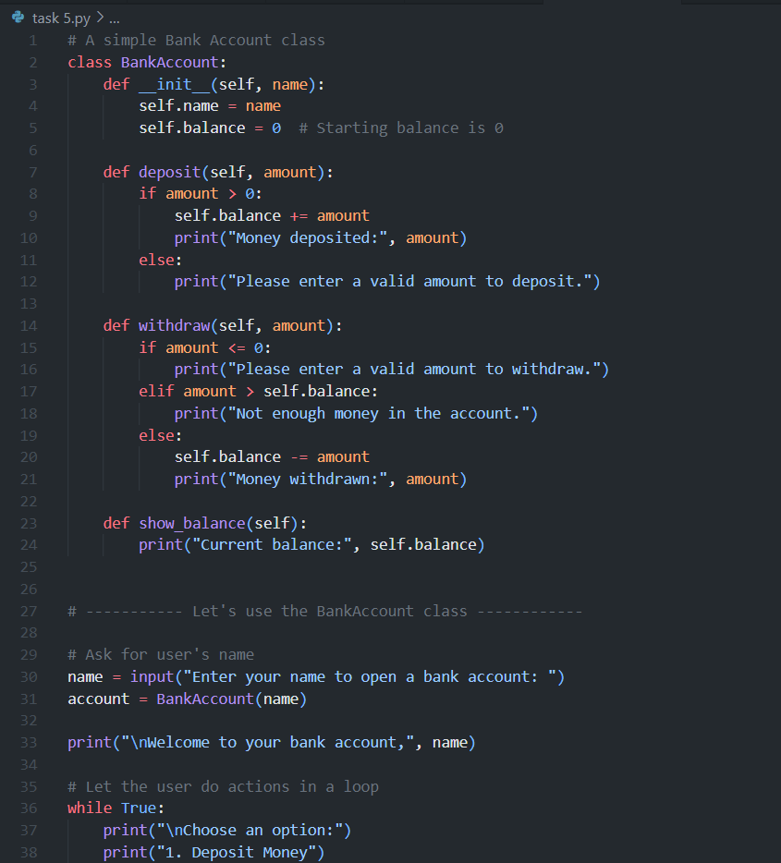  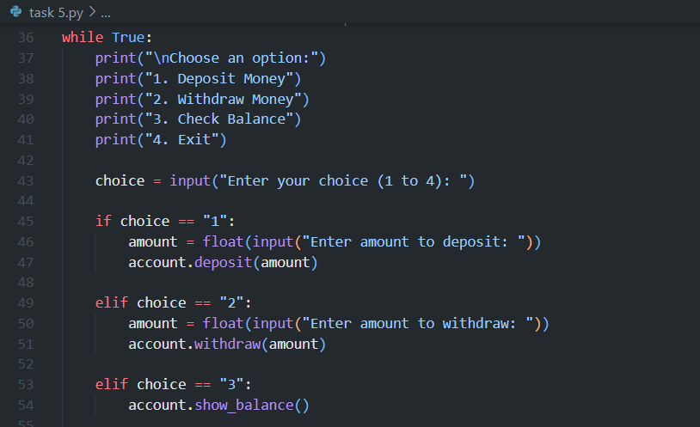  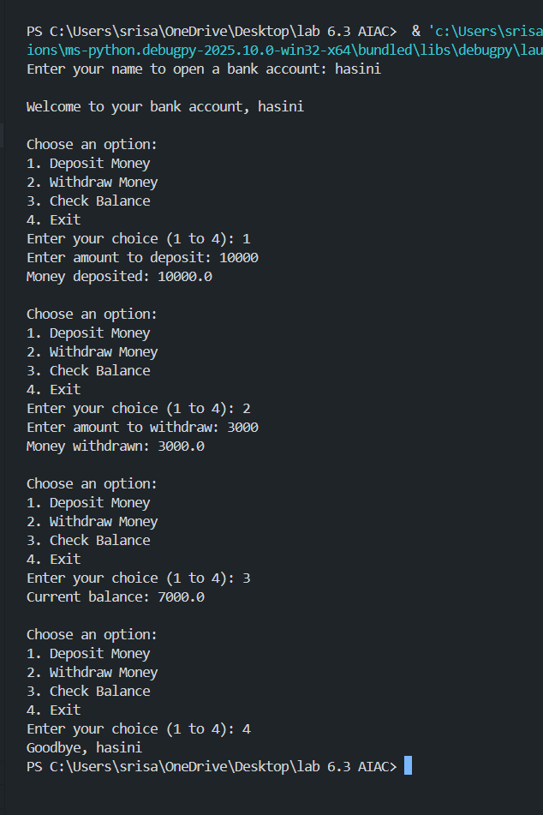  Expected Output#5  - Python code with explanation  EXPLANATION :  THE GIVEN PROMPT IS WE SHOULD GIVE THE DETAILS OF BANK ACC,WITHDRAW,DEPOSIT,AND CHECK BALANCE ,EXIT.  FOR THIS WE SHOULD USE ‘IF ELSE’ CONDITION BEACOUSE CHOICE IS GIVEN OURSELF WE SHOULD GIVE OPTIONS AND DETAILS FOR THE INPUT.SO IT WILL ASK US TO ENTER THE BANK ACC HOLDER NAME AND IT WILL ASK FOR OUR CHOICE.HERE WE MAKE OUR CHOCIES IN NUMBER WISE SO IF WE GIVE OUR CHOICE IT WILL GIVE THE DETAILS ACCORDING TO OUR CHOICE.  Note: Report should be submitted a word document for all tasks in a single document with prompts, comments & code explanation, and output and if required, screenshots  Evaluation Criteria:  Criteria Max Marks  Class 1.0  Loops 1.0  Conditional Statements 0.5  Total 2.5 Marks |  |  |  |  |  | Week3 - Wednesday

